|  |  |
| --- | --- |
| **Lab Number:** | **1** |
| **Student Name:** | **Nimesh Ambre** |
| **Roll No :** | **17** |

## Title:

To Add Two Numbers, Print Number Entered by User, Swap Two Numbers, check Whether Number is Even or Odd

* 1. Implement using C++
  2. Implement using Java

## Learning Objective:

* + - Students will be able to write C++ and java program for simple arithmetic operations and take input from user.

## Learning Outcome:

* + - * Ability to execute a simple C++ and Java program with and without any inputs to the program.
      * Understanding the constructs in C++ and Java.

Course Outcome:

Understand object-oriented programming concepts and implement using C++ and Java

**ECL304.1**

## Theory:

**Difference between procedural and object oriented language Application of object orientation**

**Brief introduction to C++ and Java**

# C++ PROGRAMS

## TO ADD TWO NUMBERS ALGORITHM:

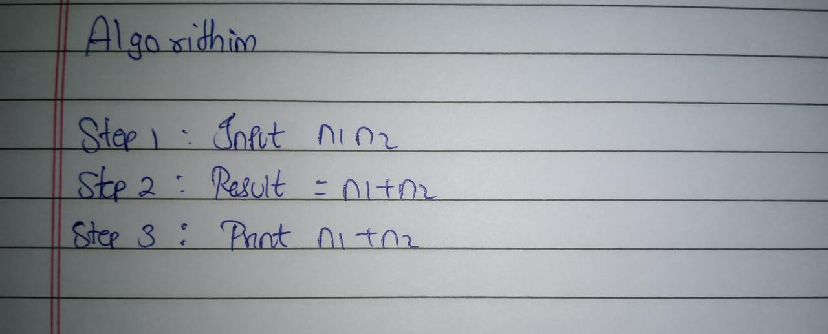

**PROGRAM:**

//To Add Two Numbers #include<iostream> using namespace std;

int main()

{

int n1, n2, result; n1=10;

n2=5;

result=n1+n2;

cout << n1 <<"+" << n2 << "=" << result; return 0;

}

## OUTPUT SCREENSHOT:

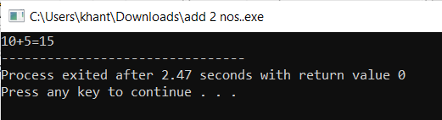

1. **TO PRINT NUMBERS ENTERED BY USER ALGORITHM:**

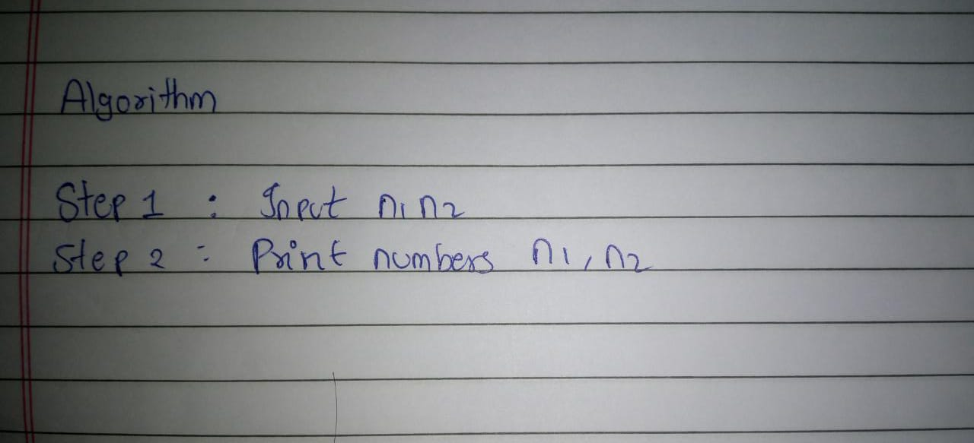

## PROGRAM:

// Print Number Entered by User #include<iostream>

using namespace std;

int main()

{

int num1,num2;

cout << "enter 2 numbers"; cin >> num1 >> num2;

cout << "user entered numbers are:" << num1 << " and " <<num2; return 0;

}

## OUTPUT SCREENSHOT:

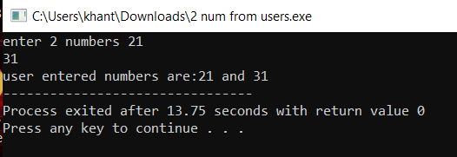

1. **TO SWAP TWO NUMBERS ALGORITHM:**

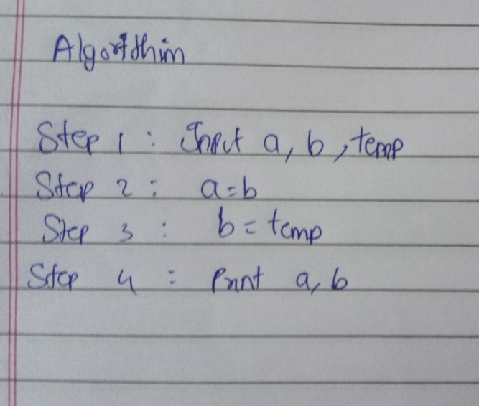

## PROGRAM:

//Swap Two Numbers #include <iostream > using namespace std; int main()

{

int a = 1, b = 2, temp; temp = a;

a = b;

b = temp;

cout << "Value of a is " <<a<<endl; cout << "Value of b is " <<b; return 0;

}

## OUTPUT SCREENSHOT:

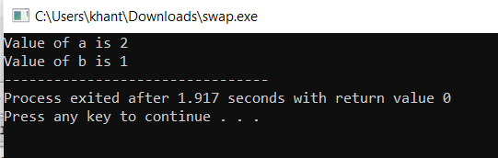

1. **TO CHECK WHETHER NUMBER IS EVEN OR ODD ALGORITHM:**

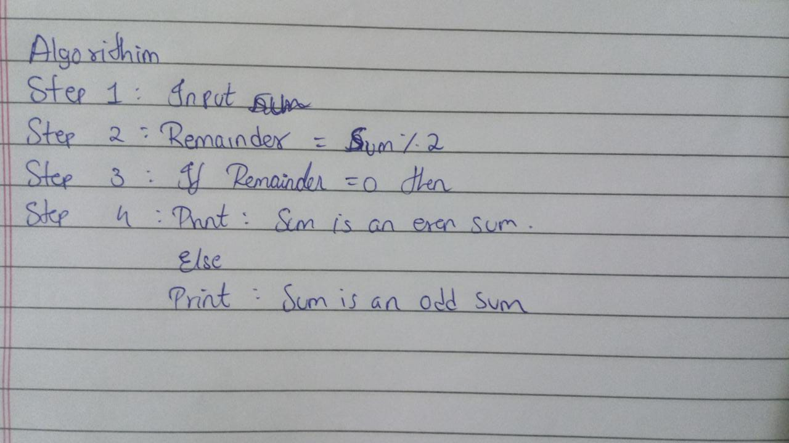

## PROGRAM:

//to check whether no is even or odd #include <iostream>

using namespace std; int main()

{

int num = 25; if(num % 2 == 0)

cout<<num<<" is even"; else

cout<<num<<" is odd"; return 0;

}

**OUTPUT SCREENSHOT:**

